CS Bridge Module 12 Recursions Part 1

1. Recursions - Part 1

1.1 CS Bridge: Recursions
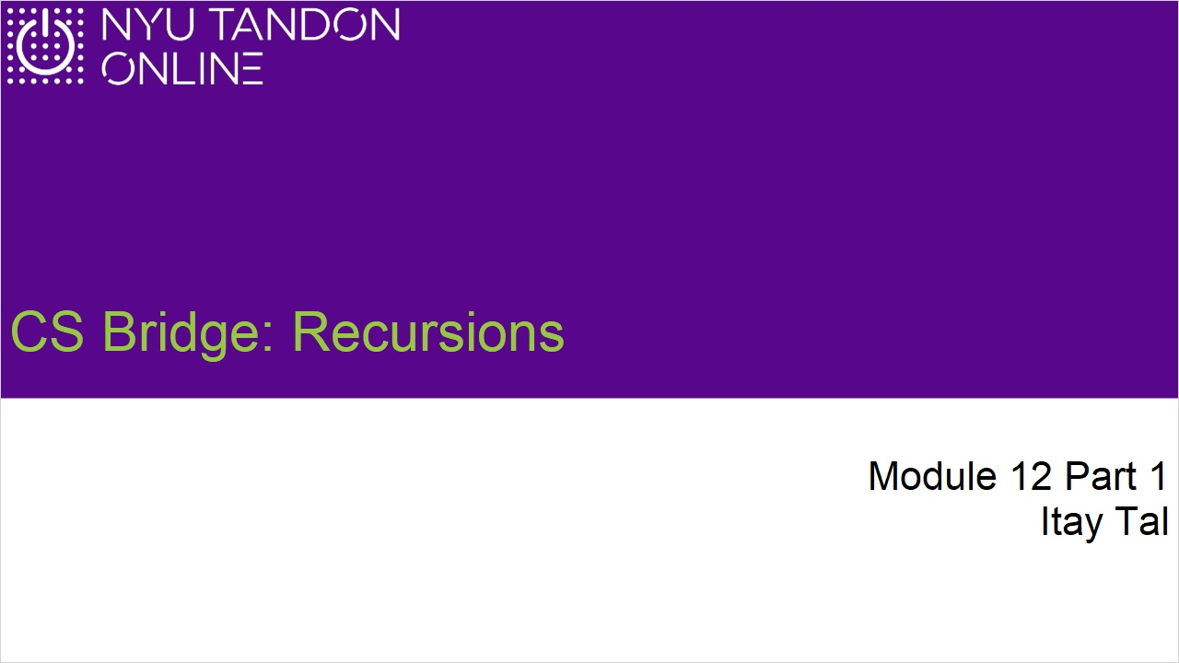

1.2 Mathematical Induction overview
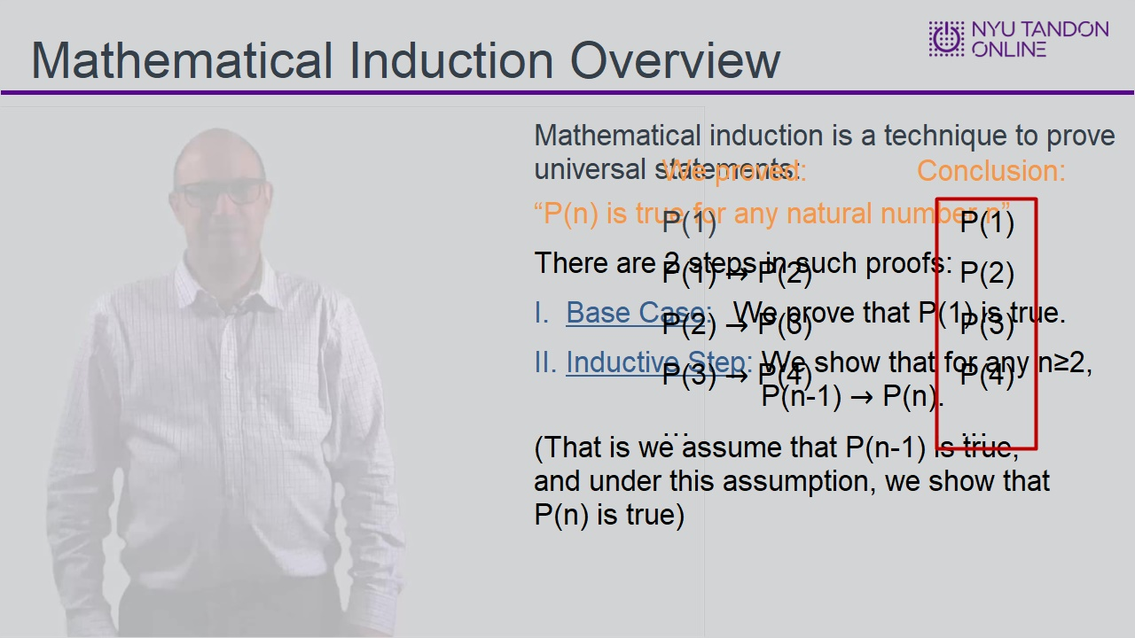
Notes:

1.3 Mathematical Induction Example
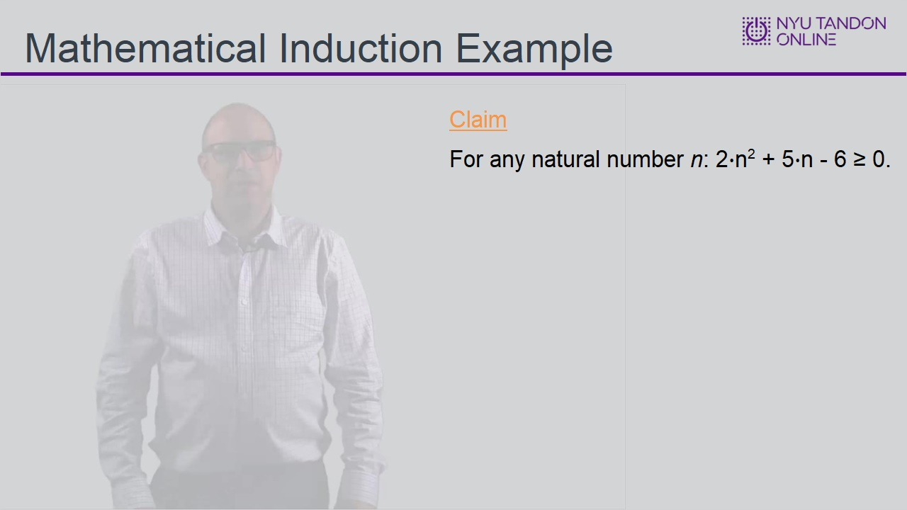

1.4 Walkthrough
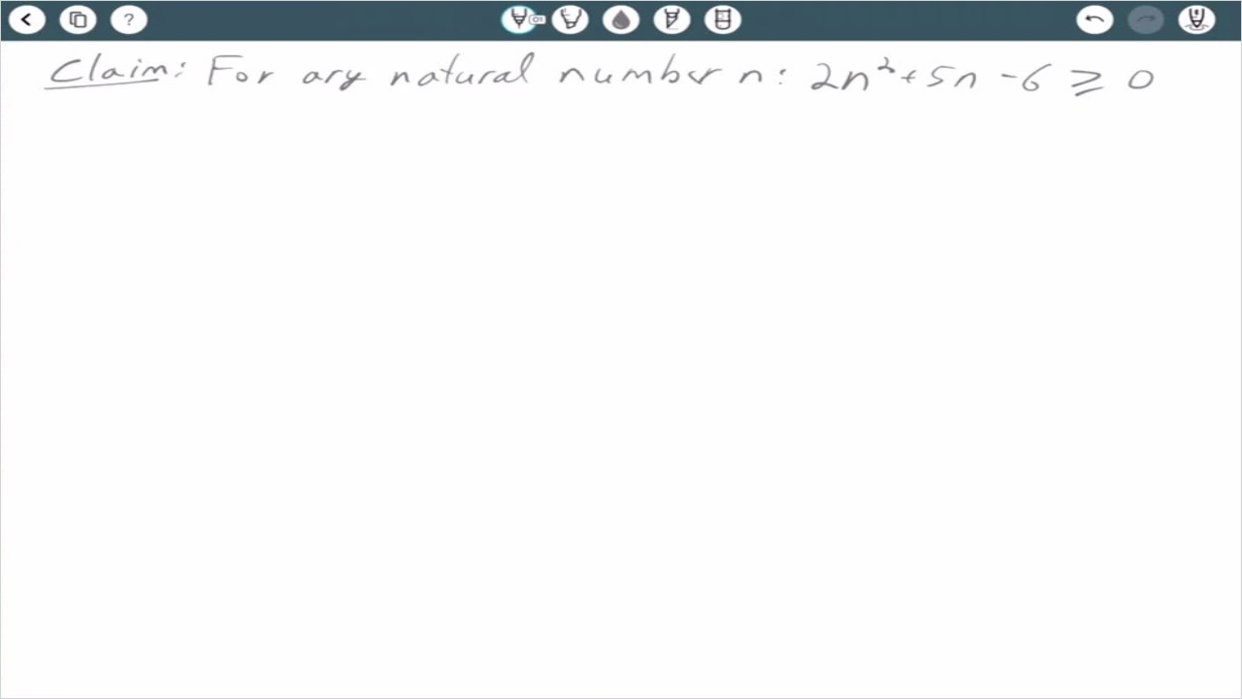
Notes:

1.5 Strong Induction Overview
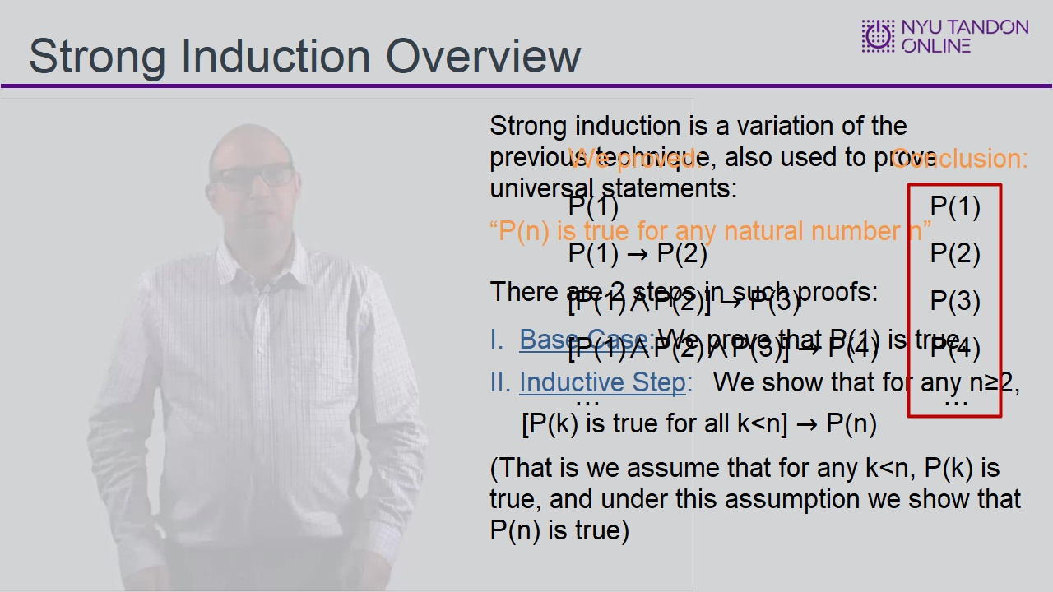

1.6 Strong Induction Example Part 1
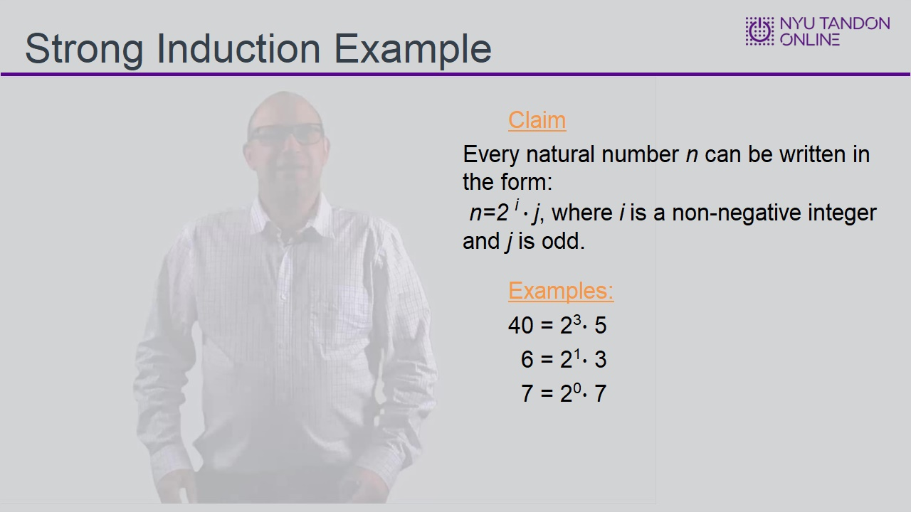

1.7 Strong Induction Example Part 2
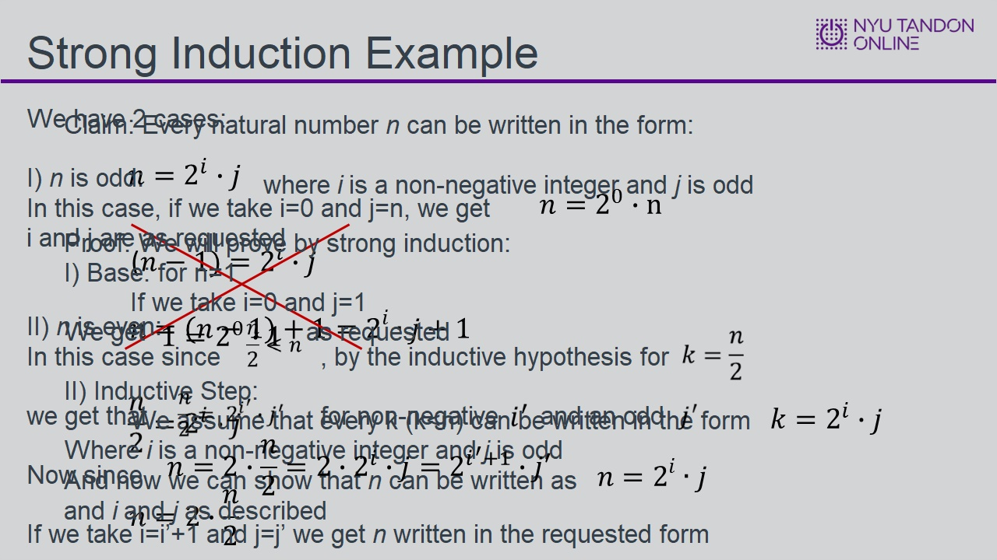
Notes:

1.8 Knowledge Check
(Sequence Drag-and-Drop, 10 points, 4 attempts permitted)
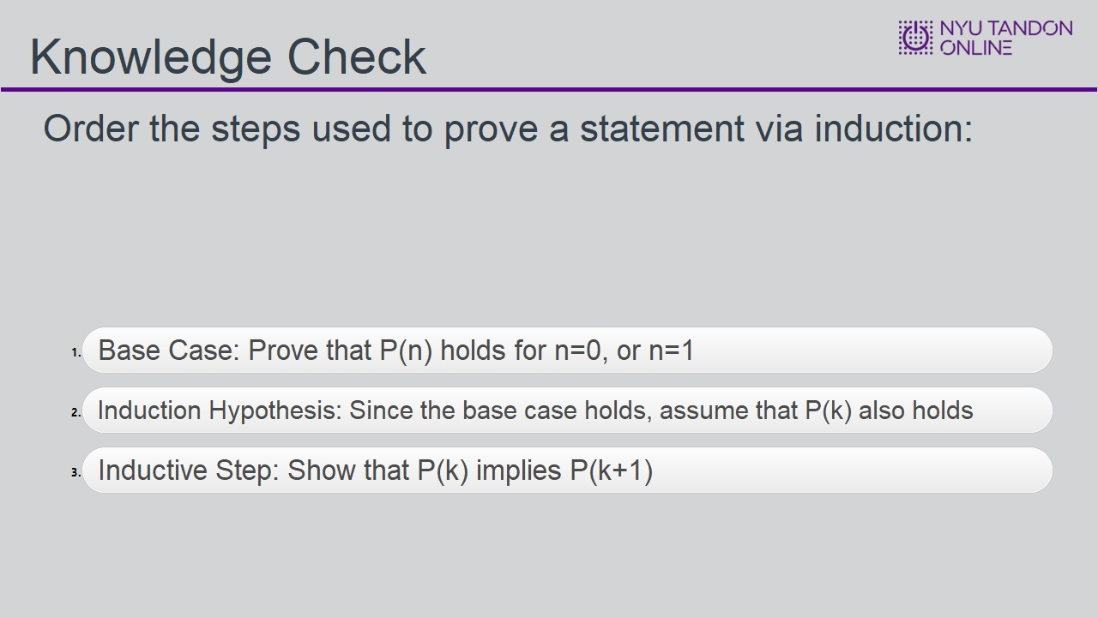
Correct Order
Base Case: Prove that P(n) holds for n=0, or n=1
Induction Hypothesis: Since the base case holds, assume that P(k) also holds
Inductive Step: Show that P(k) implies P(k+1)
Feedback when correct:
That's right! You selected the correct response.
Feedback when incorrect:
You did not select the correct response.

Correct (Slide Layer)
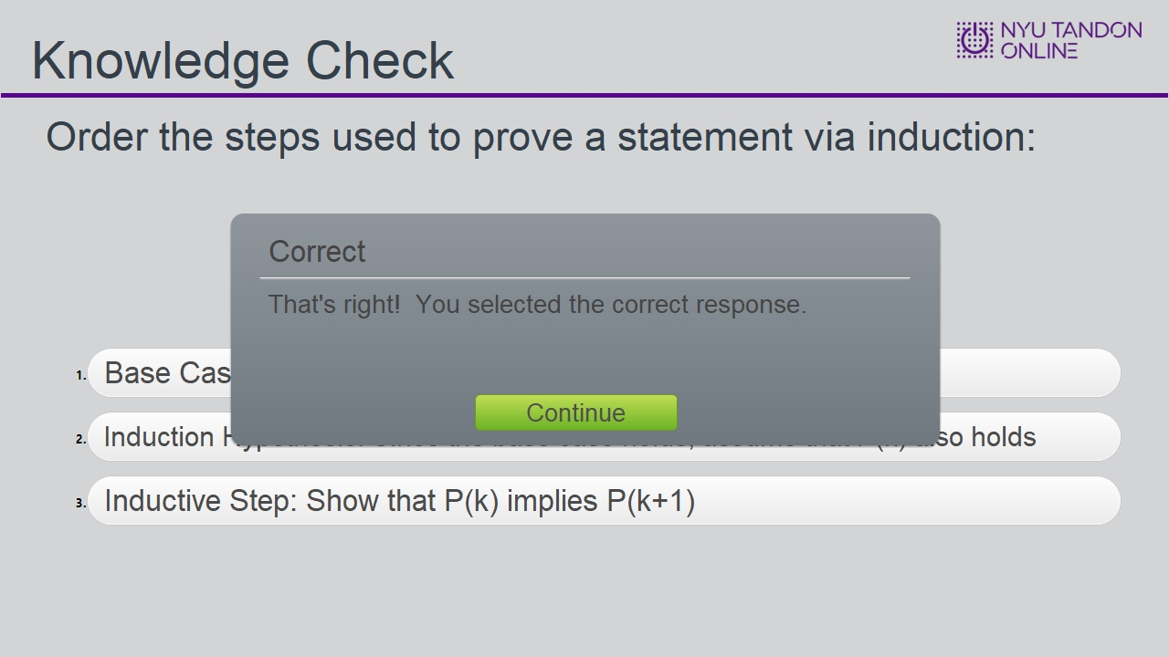

Incorrect (Slide Layer)
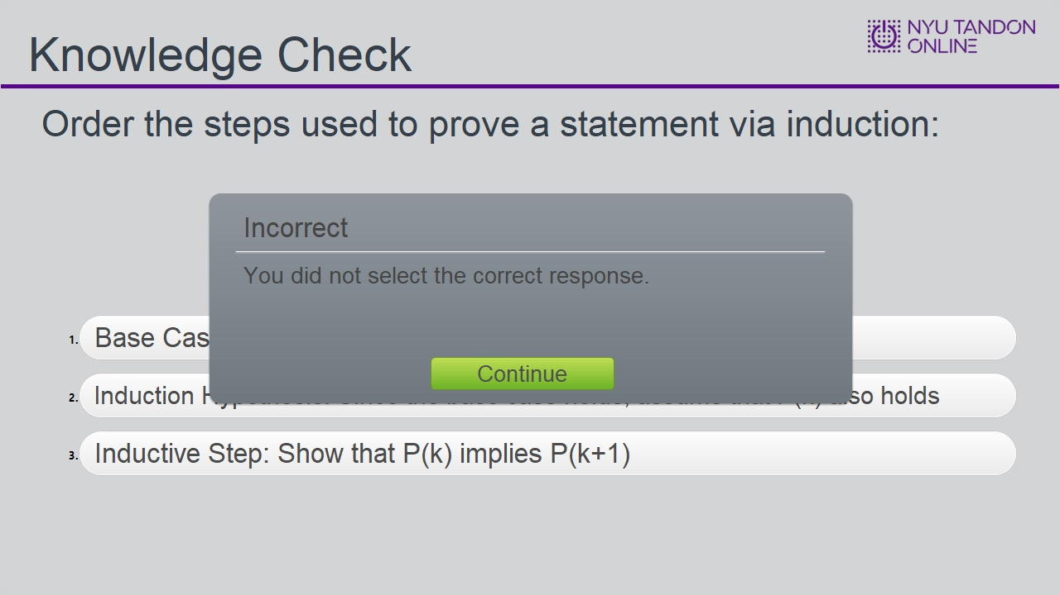

Try Again (Slide Layer)
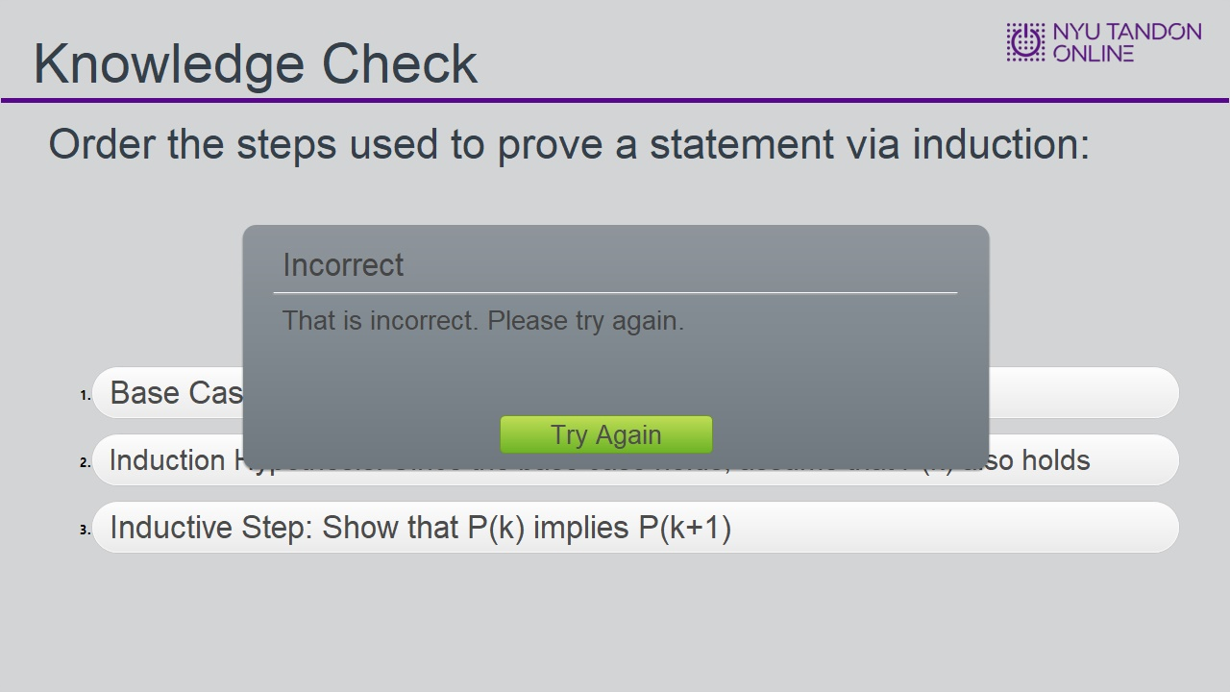

1.9 Knowledge Check
(Sequence Drag-and-Drop, 10 points, 4 attempts permitted)
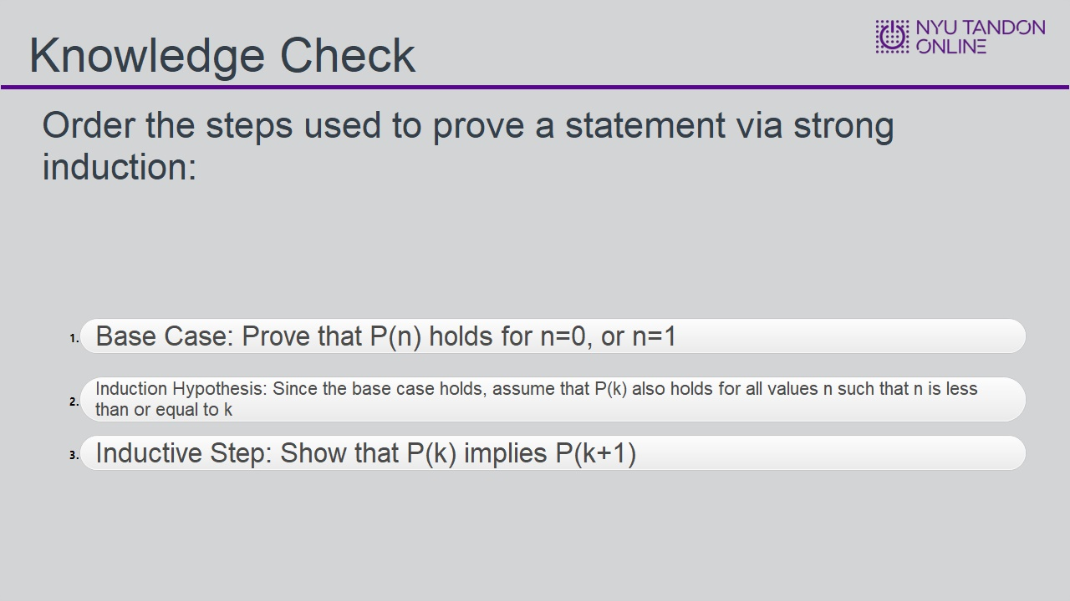
Correct Order
Base Case: Prove that P(n) holds for n=0, or n=1
Induction Hypothesis: Since the base case holds, assume that P(k) also holds for all values n such that n is less than or equal to k
Inductive Step: Show that P(k) implies P(k+1)

Feedback when correct:
That's right! You selected the correct response.
Feedback when incorrect:
You did not select the correct response.

Correct (Slide Layer)
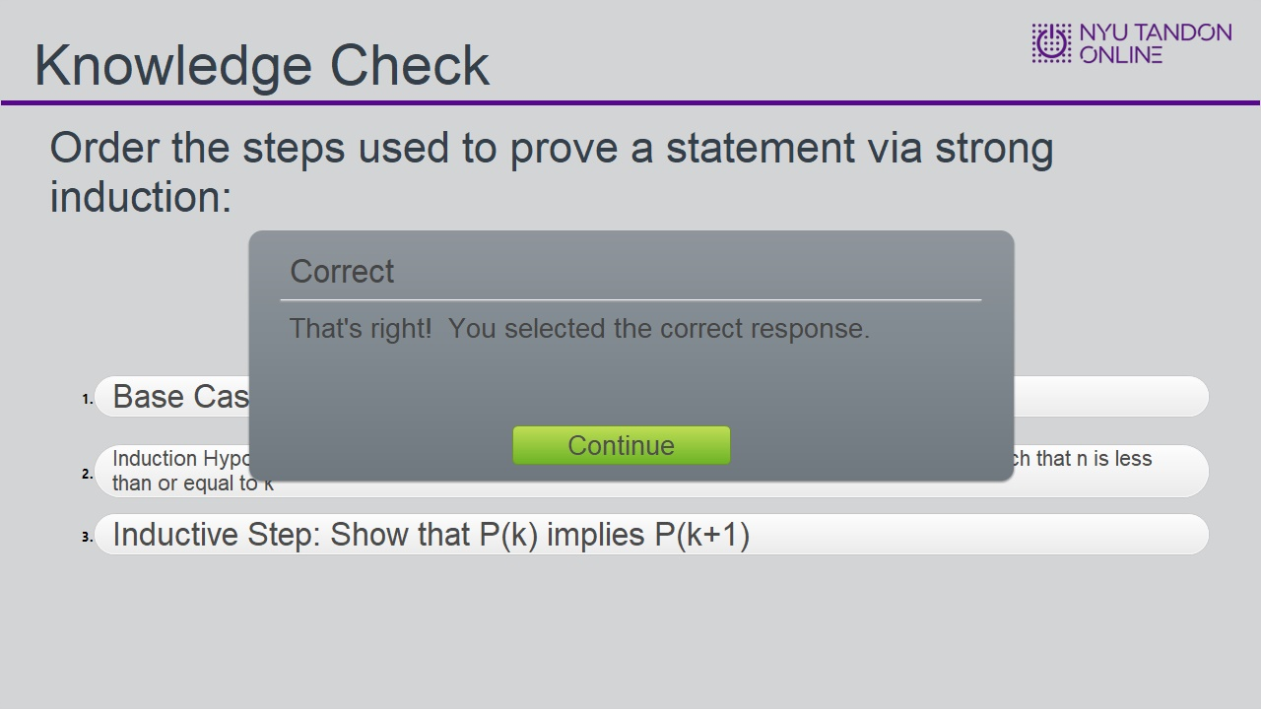

Incorrect (Slide Layer)
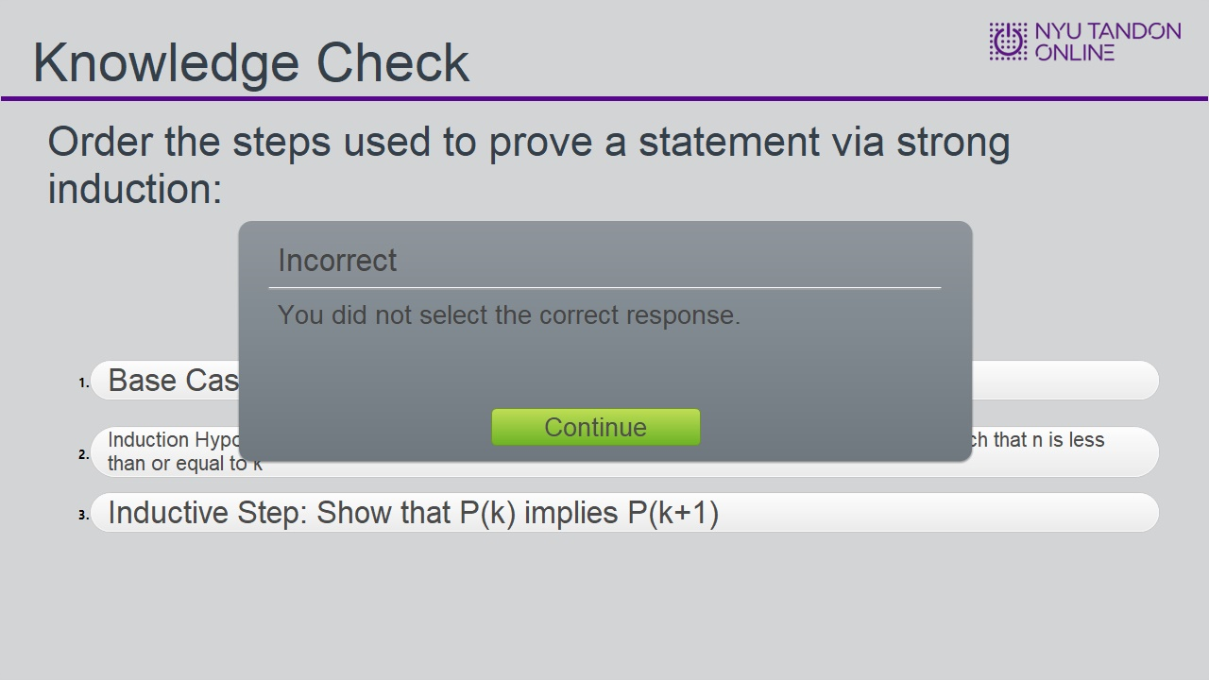

Try Again (Slide Layer)
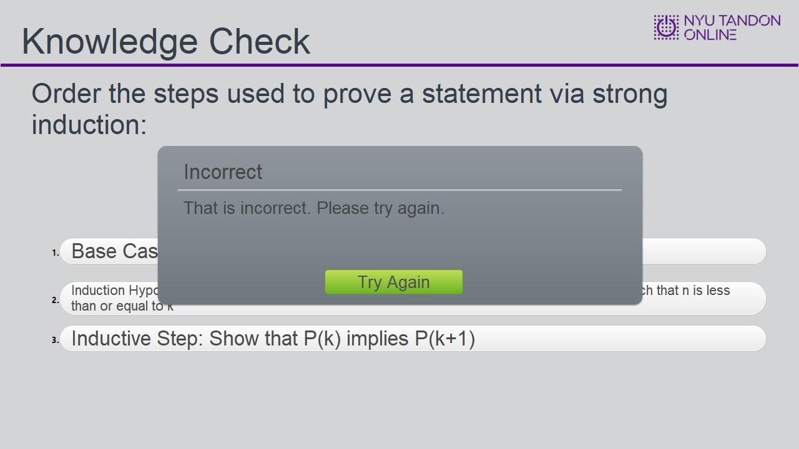

1.10 Knowledge Check
(Matching Drag-and-Drop, 10 points, 2 attempts permitted)
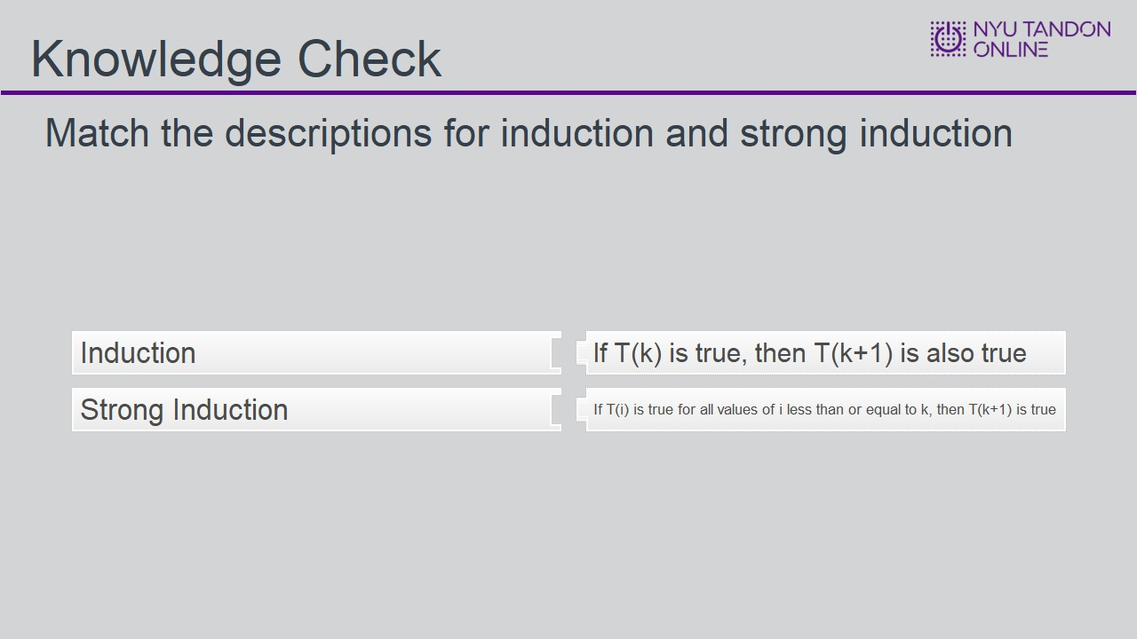
Correct | Choice
Induction | If T(k) is true, then T(k+1) is also true
Strong Induction | If T(i) is true for all values of i less than or equal to k, then T(k+1) is true

Feedback when correct:
That's right! Regular (weak) induction only considers one case to imply the final case. Strong induction considers every iteration to imply the final case.
Feedback when incorrect:
You did not select the correct response.

Correct (Slide Layer)
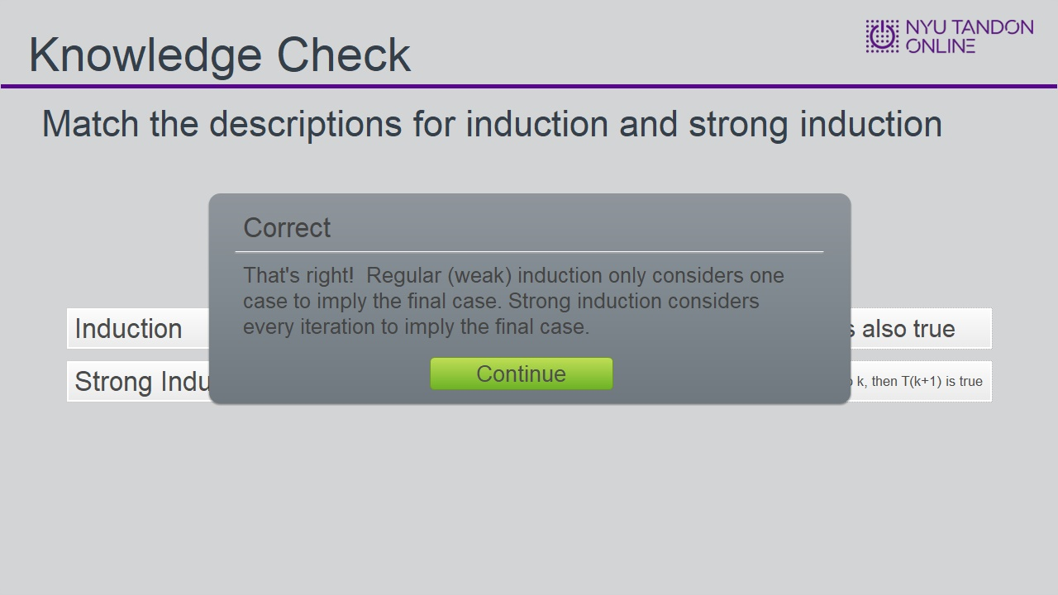

Incorrect (Slide Layer)
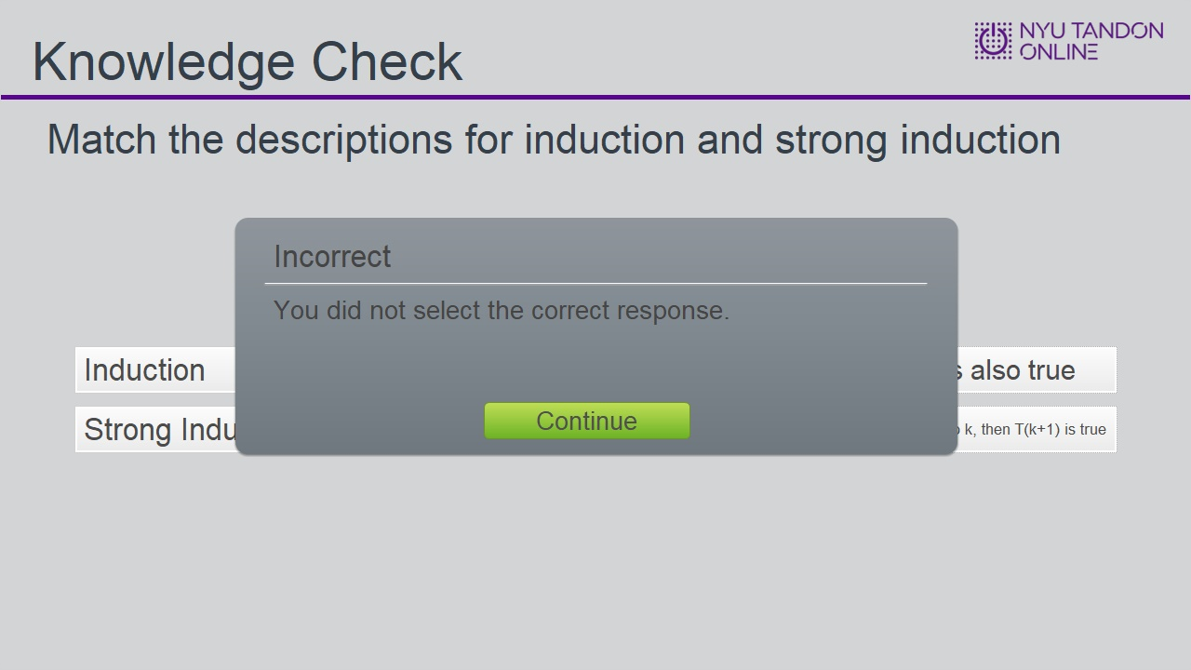

Try Again (Slide Layer)
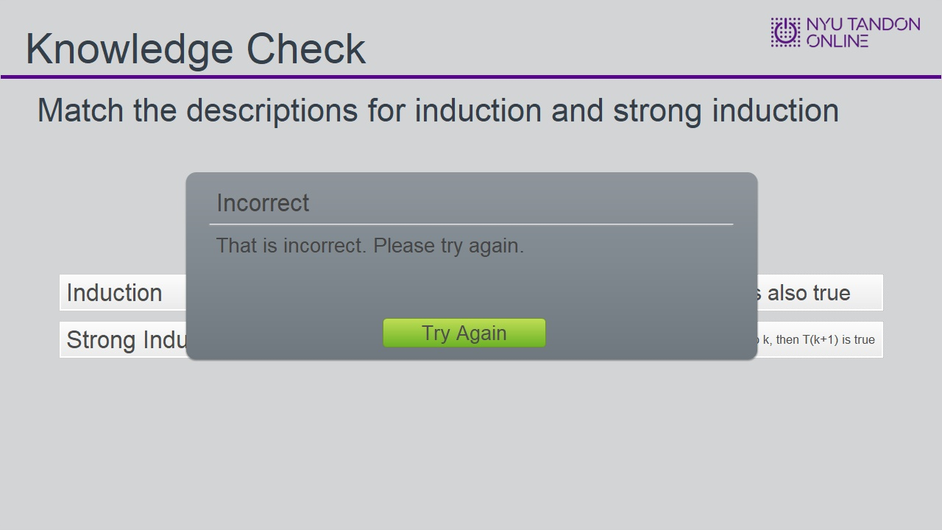

1.11 Results Slide
(Results Slide, 0 points, 1 attempt permitted)
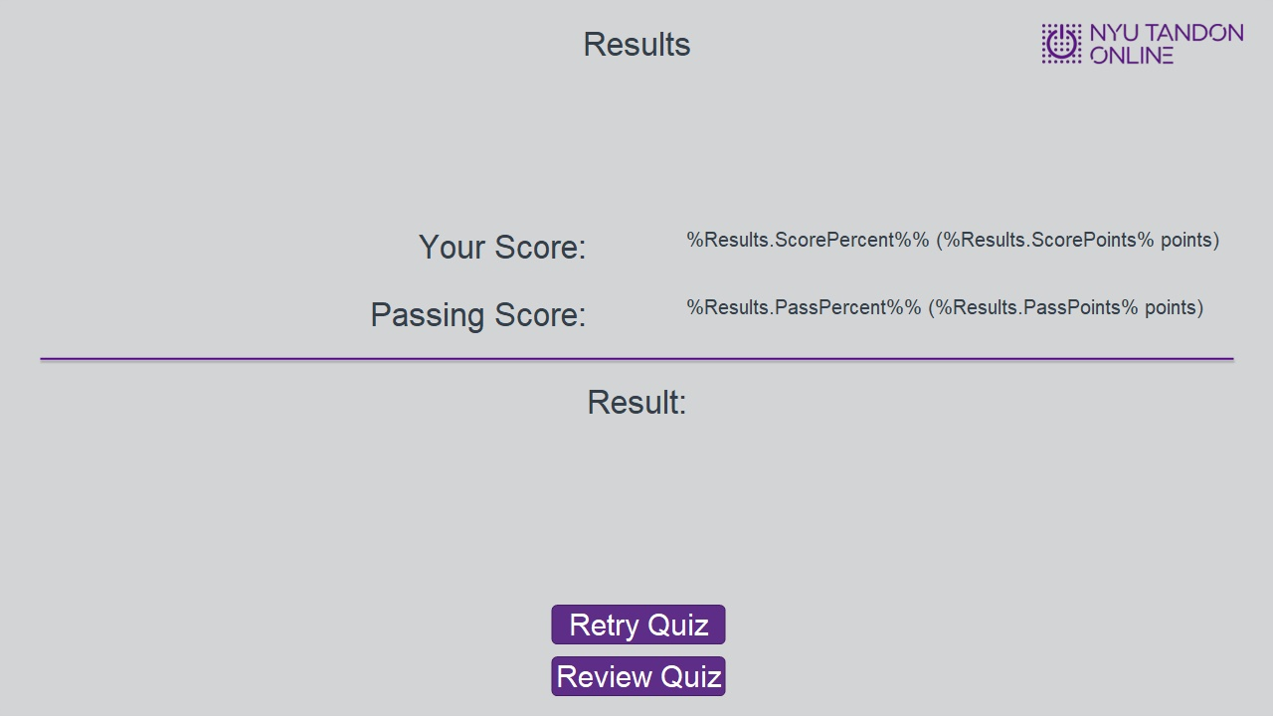

Results for
1.8 Knowledge Check
1.9 Knowledge Check
1.10 Knowledge Check

Result slide properties
Passing  Score | 80%

Success (Slide Layer)
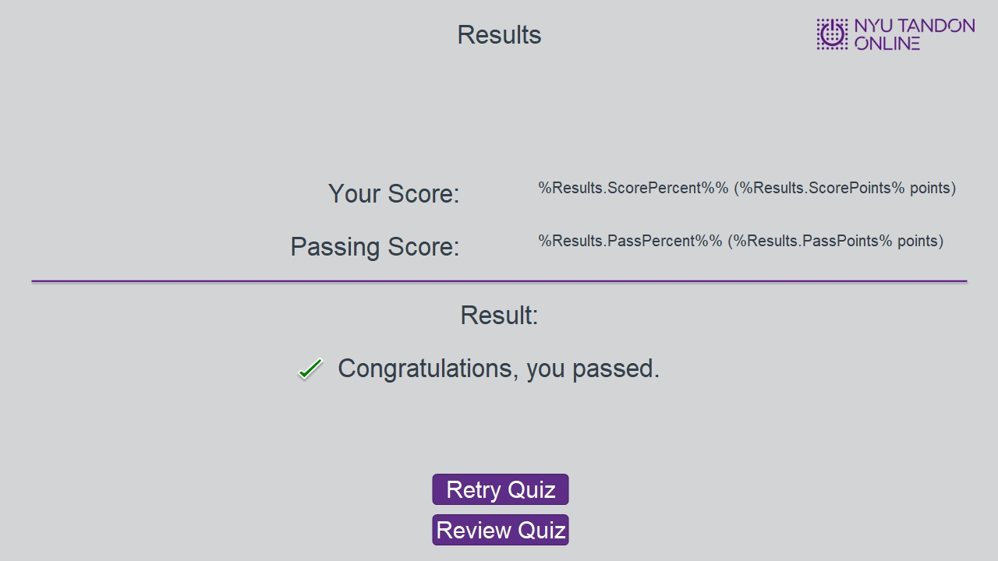

Failure (Slide Layer)
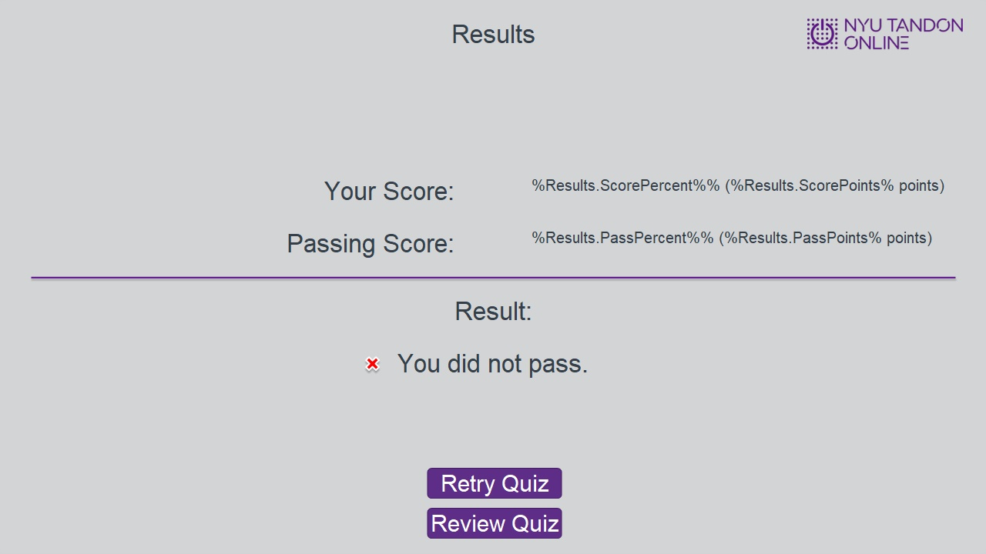

1.12 End of Module
